Project Proposal: Group 4

Group Members: Maithri Chullikana House, Richa Khagwal, Shubhangi Asati

1. Goals

a. Goal Statement:

The goal of our project is to develop an Android application that is capable of detecting stairways and doorways for indoor navigation.

b. Input:

Input would be a live video of an indoor area. The indoor area in consideration should be well lit in order to get more accurate results.

c.Output:

The application will continuously keep detecting the indoor area and **announce/warn the user about the doors and staircases**.

2. Development Platform and AVD/Device

a. Our mobile application will target Android API version 27, Android version 8.0.1, implement OpenCV version 4.0.1, and be developed in AndroidStudio version 3.5. In addition, our mobile application will be tested on a Motorola E4 plus phone and an AVD containing the target Android version 8.0.1 and API version 27.

3. Algorithms

 3.1 Overview:

We will have the following system components:

1.Capture frames from live video.

2. Apply preprocessing.

3.Doorway and stairs detection

1. Classification of stairs and doors using faster RCNN.
2. First step detection in stairs.

4.Estimation of the position of user from the detected first step of stairs/doors

5.Alert the user about position of doors/stairs

3.2  Apply preprocessing -

Will resize image inorder to pass it through the VGG16 layer and the other convolutional and fully connected layers.

For the training data, we’ll be using Coco dataset, in order to classify features as- doors and stairs.

For the testing purpose, we will take video frames in consideration.

3.3  Doorway and stairs detection in the video

Faster RCNN: We’ll use faster RCNN algorithm to detect doors and stairs in the video. It will draw the bounding box to the detected feature points.

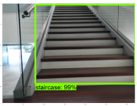

                          Fig: Stairs detected

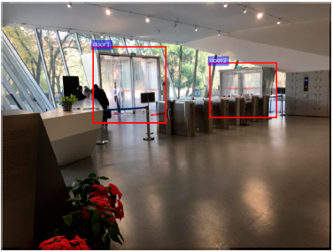

                Fig: Doors detected

3.4 First Step detection in stairs-

Using the contour detection algorithm, we will detect the first step in the stairs.

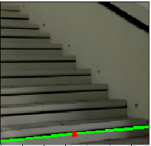

                Fig: First Step detection

Contour detection algorithm that will be using is:

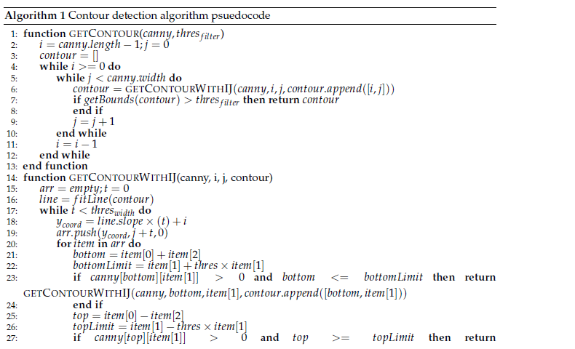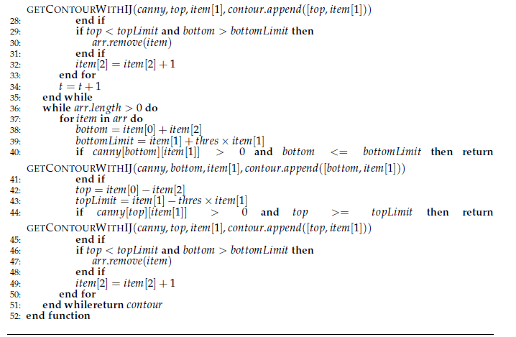

3.5 Estimation of the position of user from the detected first step of stairs/doors

We will estimate the position of the feature points from the user using the geometric relation between the smartphone camera and bounding boxes.

3.6 Alert the user about the position of doors/stairs-

We will notify user via text to speech engine about the door/stairways detected along with its direction and distance.

4.GUI Mockup:

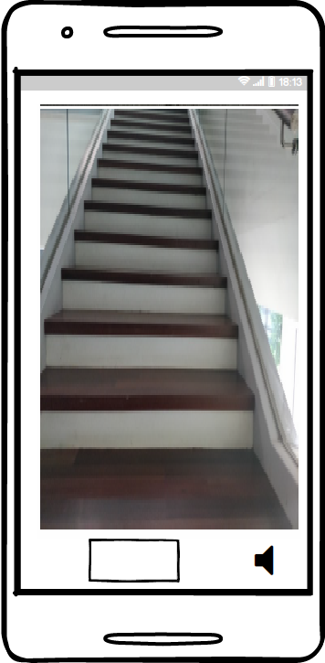

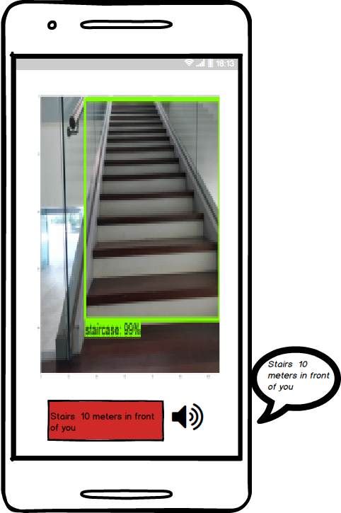

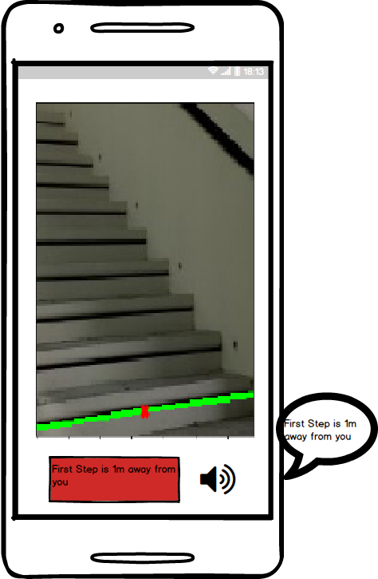

5.Resources:

1. Position and distance estimation:<https://www.mdpi.com/1424-8220/18/7/2229/htm>
2. Staircase Recognition and Localization Using Convolution Neural Network:<https://www.preprints.org/manuscript/201812.0296/v1>
3. Coco dataset:<http://cocodataset.org/#home>

[https://github.com/nightrome/cocostuff/blob/master/labels.md](https://github.com/nightrome/cocostuff/blob/master/labels.md 4)

1. Android Developer Documentation: <https://developer.android.com/>
2. OpenCV Documentation: https://opencv.org/